Changes to ClubV1 and HowDidiDo
Currently, most members are using 2 No. mobile phone apps….

- ClubV1 Members Hub for bookings, competition balances etc.
- This app is still active and can be used until later in 2026 when it’s closed, the exact date yet to be confirmed.


- HowDidiDo for bookings, members lists, playing statistics etc.
- This app is no longer active.


Going forward both these apps will merge into one new HowDidiDo app, which is currently live and ready to download.
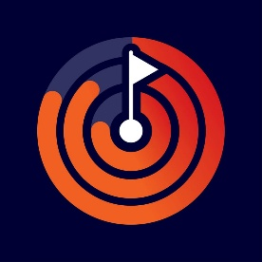

Members have 3 No. options available.
- Download and purchase this app from Play Store at a cost of £2.99 per year
- Download and purchase this app from Play Store at a cost of £9.99 per year, this is the advert free option
- Use the website link HowDidiDo.com free of charge

Please feel free to contact any committee member for further information or assistance.

